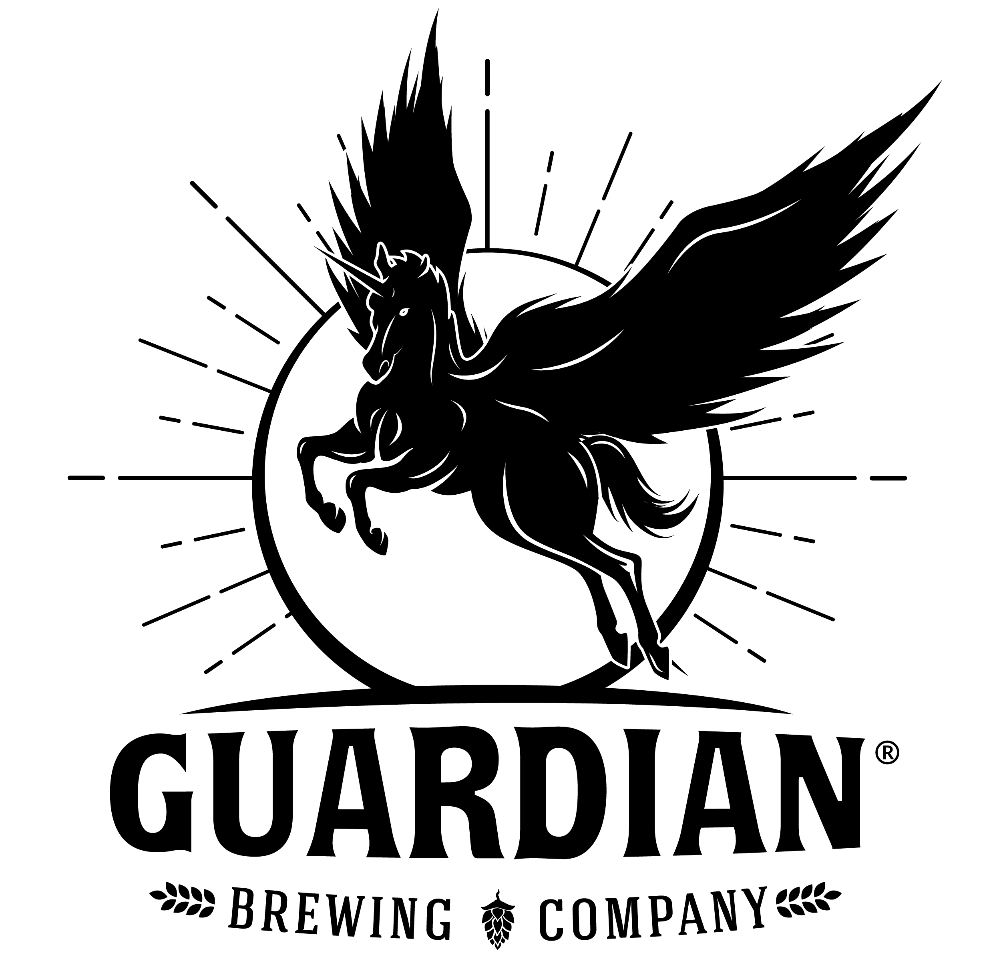
Guardian Brewing Company is hiring cooks, servers, and bartenders who have a passion for the beer and food industry and a desire to grow with our establishment. We are looking for individuals who are excited to be part of a Michigan beer culture that is diverse, innovative, and fun. We want our employees to enjoy their work and be willing to contribute their skills, personalities, and talents to a committed team and outstanding community.

Guardian is an Equal Opportunity Employer.

All Positions:
- Must be customer service oriented
- Seek honest, dependable, self-motivated team players who can multi-task and work in a fast-paced environment
- Identify and maturely communicate potential issues with co-workers and management
- Maintain an upbeat, guest-first, positive attitude
- Strive to provide a professional image and demeanor
- Ability to work days, nights, weekends, holidays, as required
- Prefer previous industry experience, but is not required

Cooks/Kitchen Staff – Basic Requests
- Prepare and cook menu items in a timely manner and to the specifications of the Head Chef
- Maintain station and kitchen cleanliness throughout shift
- Comply with health and safety regulations as well as internal policies and procedures
- Possess basic-knife-handling skills and understand product placement
- Ability to read, understand, and execute recipes given by the Head Chef
- Maintain all necessary state and local food handling requirements

Servers & Bartenders – Basic Requests
- Willingness to serve multiple tables and assist other servers as needed
- Ability to take orders and enter orders into a Point-of-Sale system in timely manner
- Ability to answer questions about the beer, wine, cider, spirits, brewery, history, etc.
- Enforce all federal, state, and local regulations
- Willingness to engage taproom guests in conversation
- Follow alcohol awareness procedures for preventing intoxication and dealing with intoxicated guests
- Ensure all financial transactions are accurate
- Product knowledge and tasting is key to providing great service and sales.
- ALL TAPROOM EMPLOYEES MUST BE 21 YEARS OF AGE TO SERVE ALCOHOL AT GUARDIAN

Hired staff are provided with incentives and discount opportunities, personal training, support and tools to reach your goals, cross-training opportunities and flexible schedules. Please indicate on the application the areas you would like to work.

Please download and complete the application. Resume attachments are also welcome. You may mail the application via post (Guardian Brewing Company 3657 63rd St., Saugatuck, MI 49453) or upload and email your server application to Dr.B@guardianbrewingco.com or your kitchen application to Chef Dan Noonan at danieln@guardianbrewingco.com.

